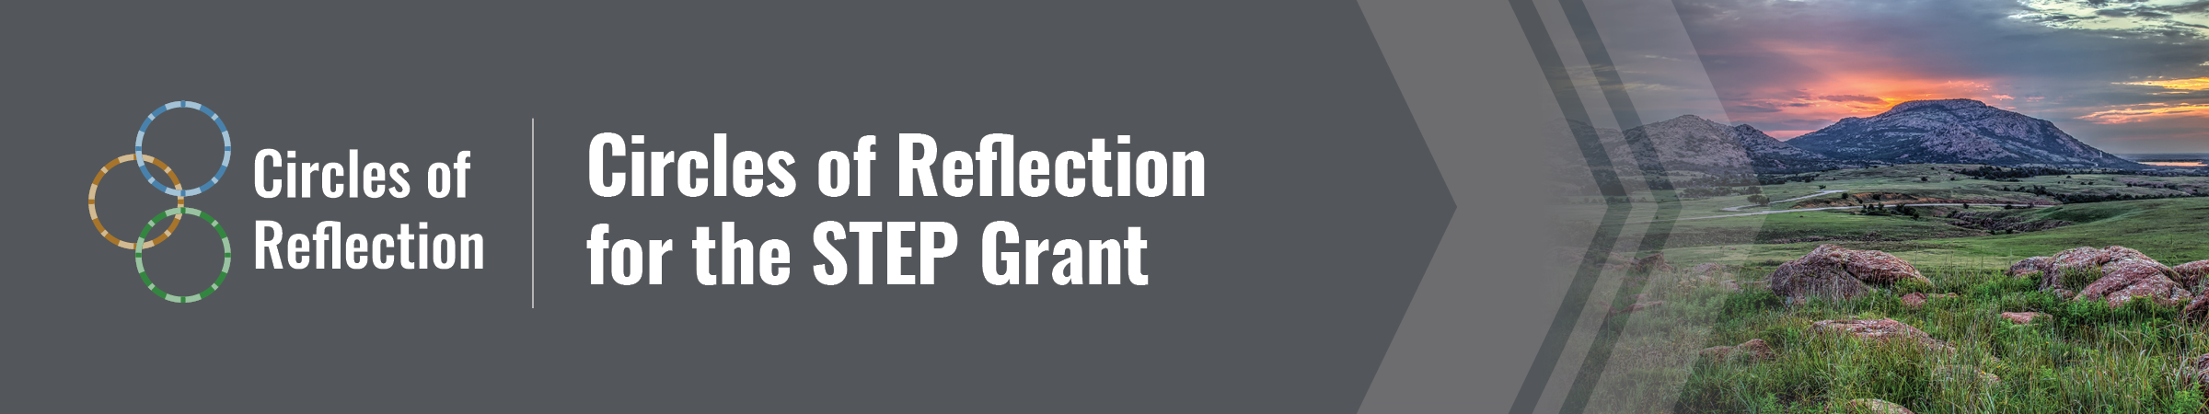
Third Circle STEP Grant Planning Worksheet
Fill in the first high-priority topic (e.g., Tribal consultation, data sharing) determined in the Second Circle, then respond to each question below to determine and demonstrate if the high-priority topic aligns to the STEP grant priorities and can be included in your STEP grant application. Complete all questions for each high-priority topic. While answering the questions, consider all the conversations from the First and Second Circle and the information collected in the Reflection Questions Worksheet.
High-Priority Topic 1:
Question | Yes/No and if Yes describe
Is this topic related to any formula grant program that could be directly administered by the Tribe?
Is this topic related to building capacity to administer and coordinate such
education programs, and to improve the Tribe’s relationship and
coordination with the SEA and LEAs that educate students from the Tribe?
Is this a topic the state/districts could receive training or support on from the Tribes?
Is this a topic the Tribe could receive training or support on from the SEA or LEAs?
Is this a topic you can build on to existing activities or resources, rather than replacing other funds?
Can you carry out other activities related to this topic, consistent with the purposes of the grant?
If the topic does not align to the grant priorities above, is this an area of focus for future collaboration?

High-Priority Topic 2:
Question | Yes/No and if Yes describe
Is this topic related to any formula grant program that could be directly administered by the Tribe?
Is this topic related to building capacity to administer and coordinate such
education programs, and to improve the Tribe’s relationship and
coordination with the SEA and LEAs that educate
students from the Tribe?
Is this a topic the state/districts could receive training or support on from the Tribes?
Is this a topic the Tribe could receive training or support on from the SEA or LEAs?
Is this a topic you can build on to existing activities or resources, rather than replacing other funds?
Can you carry out other activities related to this topic, consistent with the purposes of the grant?
If the topic does not align to the grant priorities above, is this an area of focus for future collaboration?

High-Priority Topic 3:
Question | Yes/No and if Yes describe
Is this topic related to any formula grant program that could be directly administered by the Tribe?
Is this topic related to building capacity to administer and coordinate such
education programs, and to improve the Tribe’s relationship and
coordination with the SEA and LEAs that educate students from the Tribe?
Is this a topic the state/districts could receive training or support on from the Tribes?
Is this a topic the Tribe could receive training or support on from the SEA or LEAs?
Is this a topic you can build on to existing activities or resources, rather than replacing other funds?
Can you carry out other activities related to this topic, consistent with the purposes of the grant?
If the topic does not align to the grant priorities above, is this an area of focus for future collaboration?

This document was prepared by the National Comprehensive Center under Award #S283B190028 for the Office of Program and Grantee Support Services (PGSS) within the Office of Elementary and Secondary Education of the U.S. Department of Education and is administered by Westat. The content of the document does not necessarily reflect the views or policies of the PGSS or OESE or the U.S. Department of Education. If you experience problems accessing the content in this document, please contact us.

www.compcenternetwork.org 7

